Name : Kartik Velede

Student Number : 8672807

Assignmnet : Creating and pouplating Food budget list

Below screenshot show the Food budget list

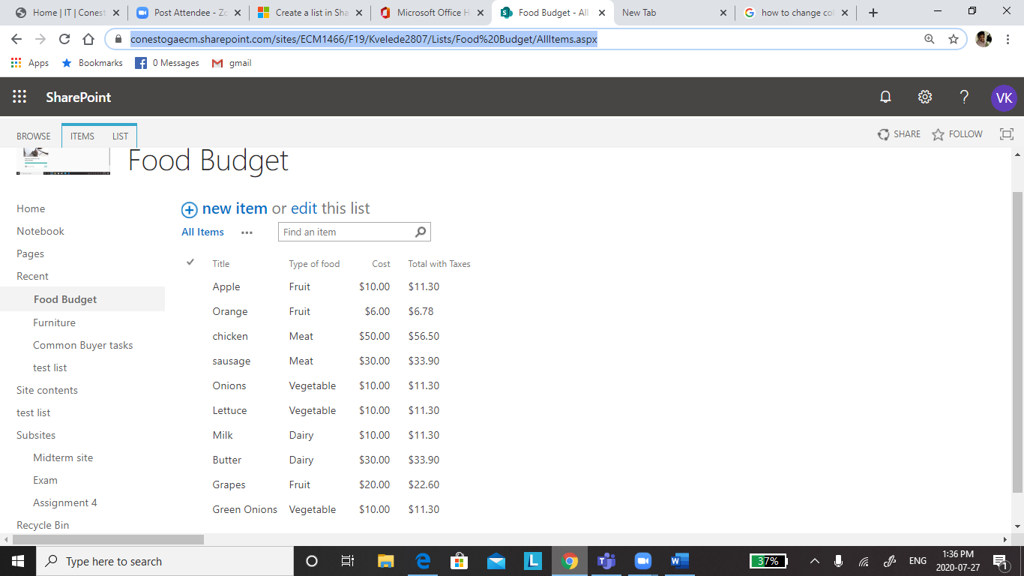

Link to direct to the Food Budget List

<https://conestogaecm.sharepoint.com/sites/ECM1466/F19/Kvelede2807/Lists/Food%20Budget/AllItems.aspx>